AQ1:
#include <iostream>
using namespace std;

struct node {
int data;
node* left;
node* right;

node(int value) {
data = value;
left = right = NULL;
}
};

node* buildTree(node* root) {
int data;
cout << "Enter the data (-1 for no node): ";
cin >> data;

if(data == -1) {
return NULL;
}

root = new node(data);

cout << "Enter data for inserting in left of " << data << endl;
root->left = buildTree(root->left);

cout << "Enter data for inserting in right of " << data << endl;
root->right = buildTree(root->right);

return root;
}

void preOrder(node* root) {
if(root == NULL) return;
cout << root->data << " ";
preOrder(root->left);
preOrder(root->right);
}

void inOrder(node* root) {
if(root == NULL) return;
inOrder(root->left);
cout << root->data << " ";
inOrder(root->right);
}

void postOrder(node* root) {
if(root == NULL) return;
postOrder(root->left);
postOrder(root->right);
cout << root->data << " ";
}

int main() {
node* root = NULL;

root = buildTree(root);

cout << "\nPre-order Traversal: ";
preOrder(root);

cout << "\nIn-order Traversal: ";
inOrder(root);

cout << "\nPost-order Traversal: ";
postOrder(root);

cout << endl;
return 0;
}

Output:
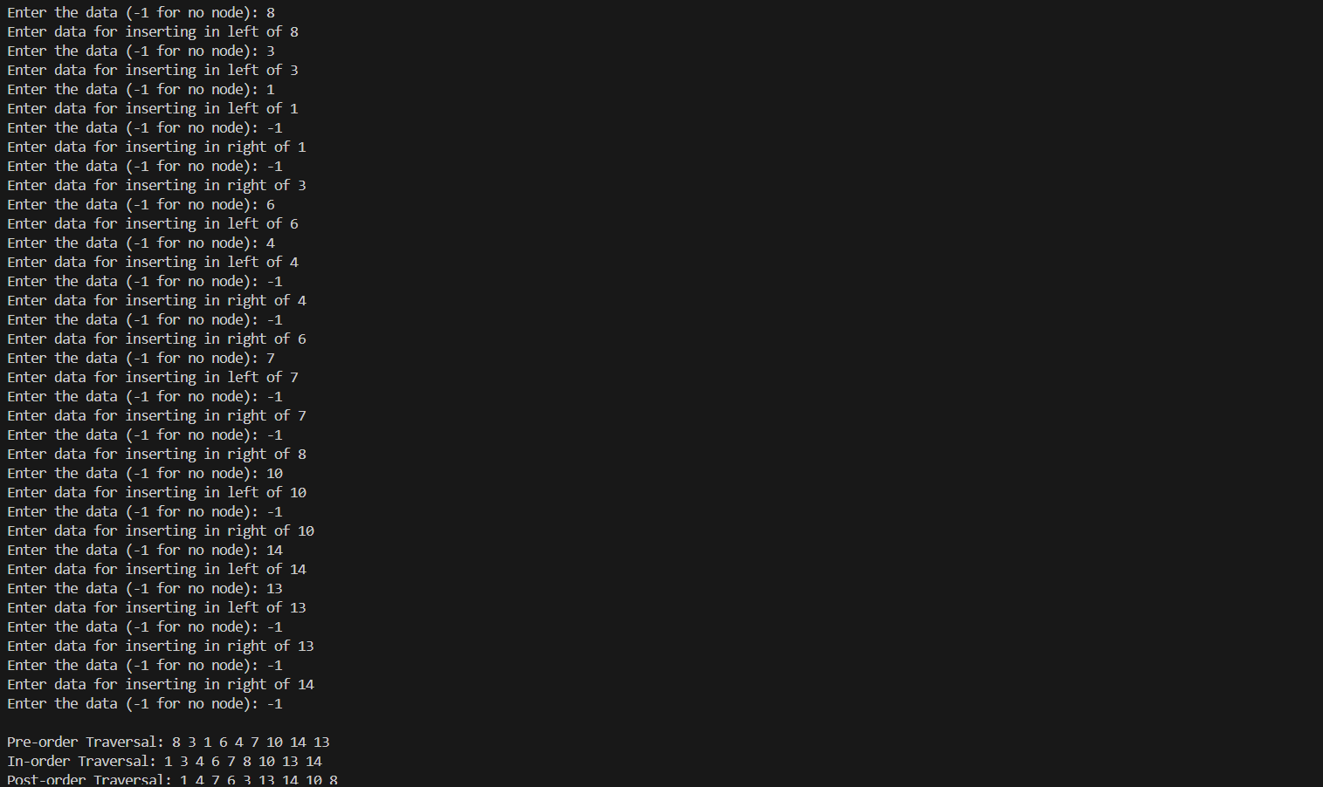
AQ2:
#include <iostream>
using namespace std;

class Node {
public:
int data;
Node* left;
Node* right;

Node(int value) {
data = value;
left = right = NULL;
}
};

// Insert data in BST (Tree creation)
Node* insert(Node* root, int value) {
if (root == NULL)
return new Node(value);

if (value < root->data)
root->left = insert(root->left, value);
else
root->right = insert(root->right, value);

return root;
}

// (a) Search Recursive
Node* searchRecursive(Node* root, int key) {
if (root == NULL || root->data == key)
return root;
if (key < root->data)
return searchRecursive(root->left, key);
return searchRecursive(root->right, key);
}

// (a) Search Iterative / Non-recursive
Node* searchIterative(Node* root, int key) {
while (root != NULL) {
if (key == root->data)
return root;
else if (key < root->data)
root = root->left;
else
root = root->right;
}
return NULL;
}

// (b) Maximum element of BST
Node* maxNode(Node* root) {
while (root && root->right)
root = root->right;
return root;
}

// (c) Minimum element of BST
Node* minNode(Node* root) {
while (root && root->left)
root = root->left;
return root;
}

// (d) In-order Successor
Node* inorderSuccessor(Node* root, Node* target) {
if (target->right != NULL)
return minNode(target->right);

Node* successor = NULL;
while (root != NULL) {
if (target->data < root->data) {
successor = root;
root = root->left;
}
else if (target->data > root->data)
root = root->right;
else
break;
}
return successor;
}

// (e) In-order Predecessor
Node* inorderPredecessor(Node* root, Node* target) {
if (target->left != NULL)
return maxNode(target->left);

Node* predecessor = NULL;
while (root != NULL) {
if (target->data > root->data) {
predecessor = root;
root = root->right;
}
else if (target->data < root->data)
root = root->left;
else
break;
}
return predecessor;
}

// Traversal to verify Tree formation
void inorder(Node* root) {
if (root == NULL) return;
inorder(root->left);
cout << root->data << " ";
inorder(root->right);
}

int main() {
Node* root = NULL;
int n, value;

cout << "Enter number of nodes: ";
cin >> n;

cout << "Enter values: ";
for (int i = 0; i < n; i++) {
cin >> value;
root = insert(root, value);
}

cout << "\nBST (In-order Traversal): ";
inorder(root);
cout << endl;

int key;
cout << "\nEnter element to search: ";
cin >> key;

cout << "Recursive Search: ";
cout << (searchRecursive(root, key) ? "Found" : "Not Found") << endl;

cout << "Iterative Search: ";
cout << (searchIterative(root, key) ? "Found" : "Not Found") << endl;

cout << "\nMinimum element = " << minNode(root)->data << endl;
cout << "Maximum element = " << maxNode(root)->data << endl;

Node* target = searchRecursive(root, key);
if (target != NULL) {
Node* succ = inorderSuccessor(root, target);
Node* pred = inorderPredecessor(root, target);

cout << "\nIn-order Successor of " << key << ": ";
if (succ) cout << succ->data; else cout << "None";

cout << "\nIn-order Predecessor of " << key << ": ";
if (pred) cout << pred->data; else cout << "None";
}

cout << endl;
return 0;
}

Output:
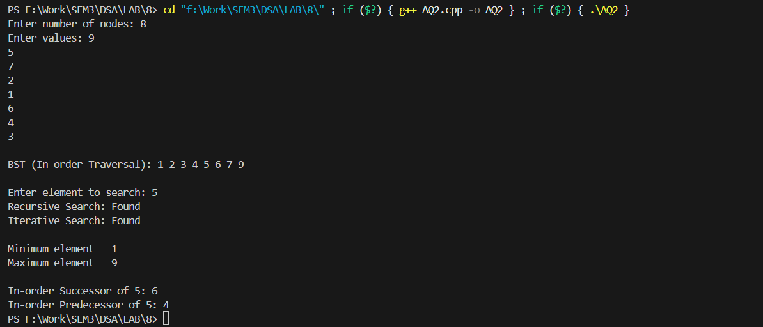
AQ3:
#include <iostream>
#include <algorithm>
using namespace std;

class Node {
public:
int data;
Node* left;
Node* right;

Node(int value) {
data = value;
left = right = NULL;
}
};

// (a) INSERT (No duplicates allowed)
Node* insert(Node* root, int value) {
if (root == NULL)
return new Node(value);

if (value < root->data)
root->left = insert(root->left, value);
else if (value > root->data)
root->right = insert(root->right, value);
else
cout << "Duplicate not allowed: " << value << endl;

return root;
}

// Find min node (used for delete)
Node* minNode(Node* root) {
while (root->left != NULL)
root = root->left;
return root;
}

// (b) DELETE element
Node* deleteNode(Node* root, int key) {
if (root == NULL)
return root;

if (key < root->data)
root->left = deleteNode(root->left, key);
else if (key > root->data)
root->right = deleteNode(root->right, key);
else { // Node found

// Case 1: No child / 1 child
if (root->left == NULL) {
Node* temp = root->right;
delete root;
return temp;
}
if (root->right == NULL) {
Node* temp = root->left;
delete root;
return temp;
}

// Case 2: 2 children → replace with inorder successor
Node* temp = minNode(root->right);
root->data = temp->data;
root->right = deleteNode(root->right, temp->data);
}
return root;
}

// (c) MAXIMUM depth of BST
int maxDepth(Node* root) {
if (root == NULL)
return 0;
return 1 + max(maxDepth(root->left), maxDepth(root->right));
}

// (d) MINIMUM depth of BST
int minDepth(Node* root) {
if (root == NULL)
return 0;

// If one child is NULL, consider the depth of the other child
if (root->left == NULL)
return 1 + minDepth(root->right);
if (root->right == NULL)
return 1 + minDepth(root->left);

return 1 + min(minDepth(root->left), minDepth(root->right));
}

// Inorder traversal (for display)
void inorder(Node* root) {
if (root == NULL) return;
inorder(root->left);
cout << root->data << " ";
inorder(root->right);
}

int main() {
Node* root = NULL;
int choice, value;

while (true) {
cout << "\n------ BST MENU ------";
cout << "\n1. Insert";
cout << "\n2. Delete";
cout << "\n3. Display (In-order)";
cout << "\n4. Maximum Depth";
cout << "\n5. Minimum Depth";
cout << "\n6. Exit";
cout << "\nEnter choice: ";
cin >> choice;

switch (choice) {
case 1:
cout << "Enter value to insert: ";
cin >> value;
root = insert(root, value);
break;

case 2:
cout << "Enter value to delete: ";
cin >> value;
root = deleteNode(root, value);
break;

case 3:
cout << "\nBST in-order: ";
inorder(root);
cout << endl;
break;

case 4:
cout << "Maximum Depth of BST = " << maxDepth(root) << endl;
break;

case 5:
cout << "Minimum Depth of BST = " << minDepth(root) << endl;
break;

case 6:
return 0;

default:
cout << "Invalid choice!";
}
}
}

Output: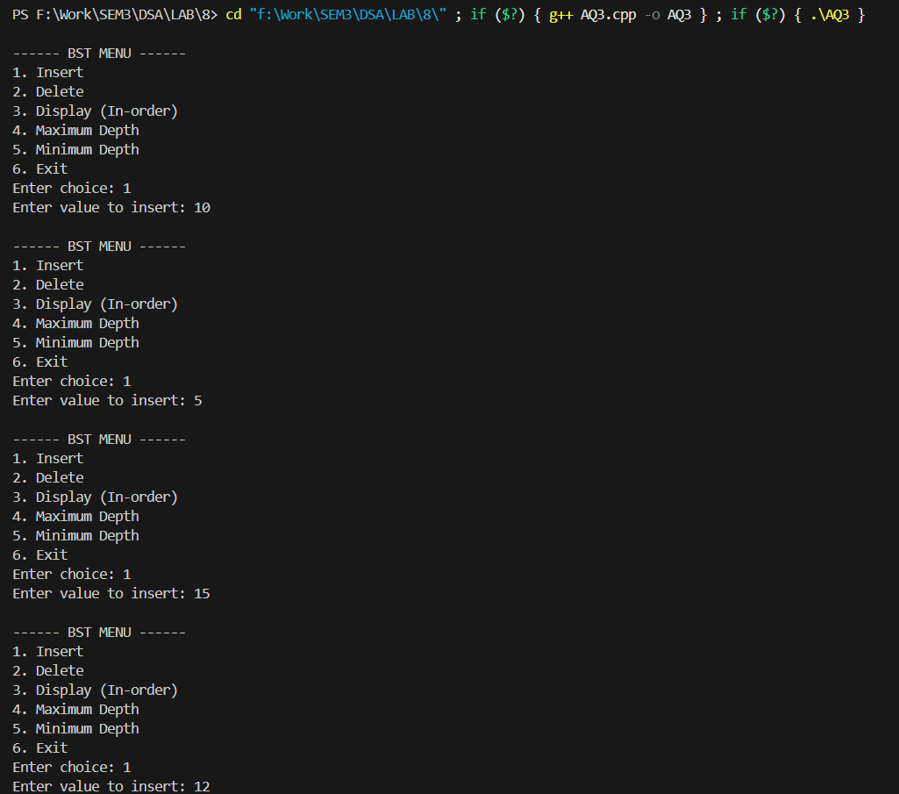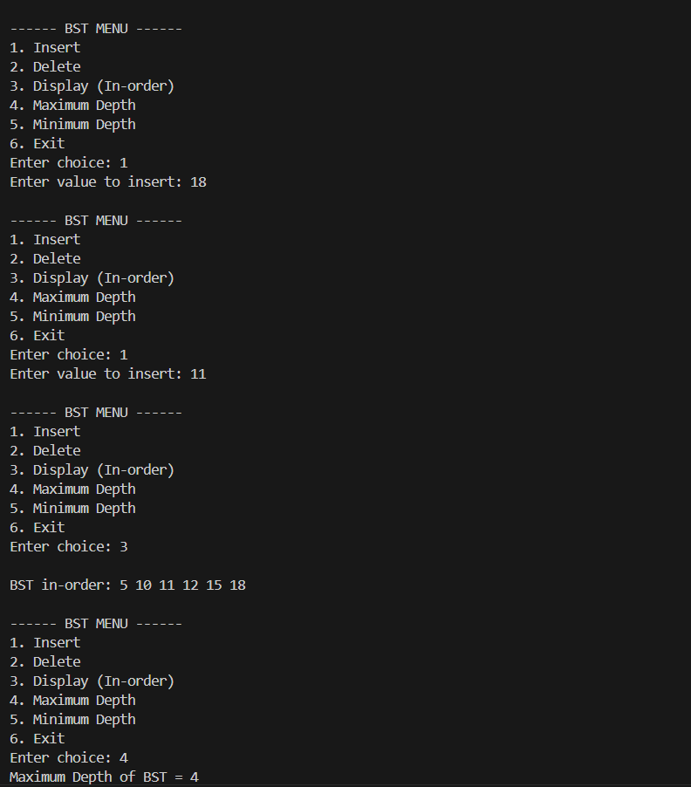
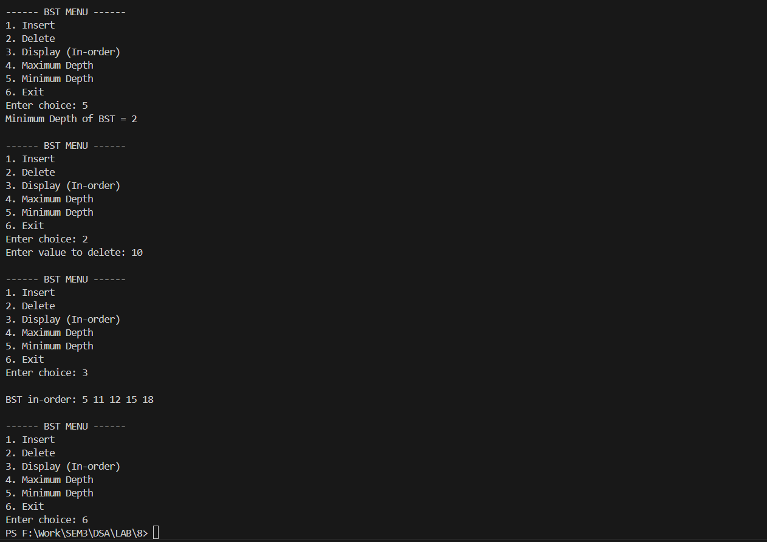
AQ4:
#include <iostream>
#include <climits>
using namespace std;

class Node {
public:
int data;
Node* left;
Node* right;

Node(int value) {
data = value;
left = right = NULL;
}
};

Node* insertBinaryTree() {
int value;
cout << "Enter data (-1 for no node): ";
cin >> value;

if (value == -1)
return NULL;

Node* root = new Node(value);

cout << "Enter left child of " << value << endl;
root->left = insertBinaryTree();

cout << "Enter right child of " << value << endl;
root->right = insertBinaryTree();

return root;
}

bool isBSTUtil(Node* root, long long &prev) {
if (root == NULL)
return true;

if (!isBSTUtil(root->left, prev))
return false;

if (root->data <= prev)
return false;
prev = root->data;

return isBSTUtil(root->right, prev);
}

bool isBST(Node* root) {
long long prev = LLONG_MIN;
return isBSTUtil(root, prev);
}

int main() {
cout << "Create Binary Tree:\n";
Node* root = insertBinaryTree();

if (isBST(root))
cout << "\nThe given binary tree IS a BST\n";
else
cout << "\nThe given binary tree is NOT a BST\n";

return 0;
}

Output:
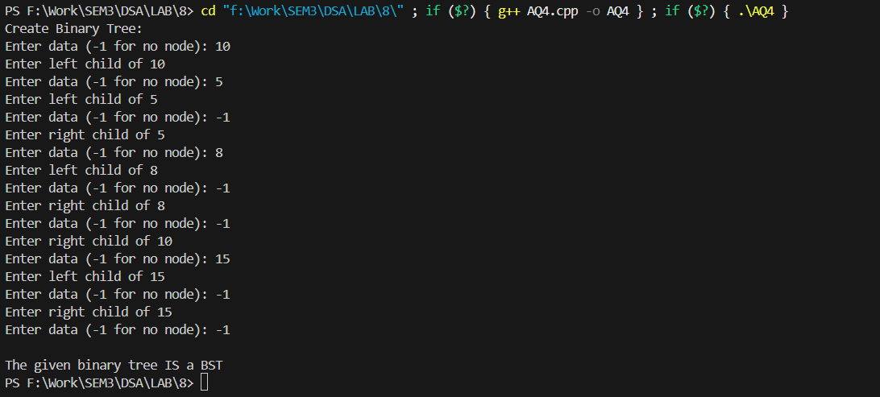

AQ5:
#include <iostream>
using namespace std;

void heapify(int arr[], int n, int i, bool increasing) {
int extreme = i;
int left = 2 * i + 1;
int right = 2 * i + 2;

if (increasing) {
if (left < n && arr[left] > arr[extreme])
extreme = left;
if (right < n && arr[right] > arr[extreme])
extreme = right;
} else {
if (left < n && arr[left] < arr[extreme])
extreme = left;
if (right < n && arr[right] < arr[extreme])
extreme = right;
}

if (extreme != i) {
swap(arr[i], arr[extreme]);
heapify(arr, n, extreme, increasing);
}
}

void heapSort(int arr[], int n, bool increasing) {
for (int i = n / 2 - 1; i >= 0; i--)
heapify(arr, n, i, increasing);

for (int i = n - 1; i > 0; i--) {
swap(arr[0], arr[i]);
heapify(arr, i, 0, increasing);
}
}

int main() {
int n;
cout << "Enter number of elements: ";
cin >> n;

int arr[n];
cout << "Enter elements: ";
for (int i = 0; i < n; i++)
cin >> arr[i];

int choice;
cout << "\n1. Increasing Order\n2. Decreasing Order\nEnter choice: ";
cin >> choice;

if (choice == 1)
heapSort(arr, n, true);
else
heapSort(arr, n, false);

cout << "\nSorted Array: ";
for (int i = 0; i < n; i++)
cout << arr[i] << " ";
cout << endl;

return 0;
}

Output:
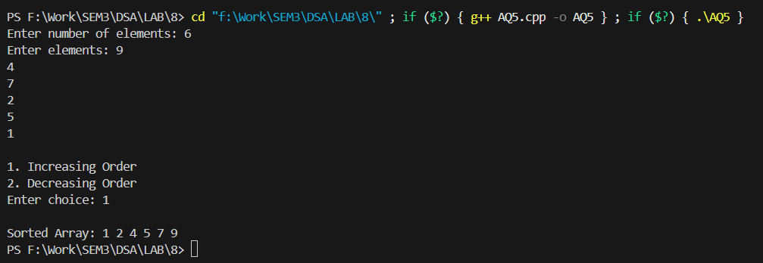
AQ6:
#include <iostream>
using namespace std;

int heap[100];
int size = 0;

void insert(int value) {
size++;
heap[size] = value;
int i = size;

while (i > 1 && heap[i/2] < heap[i]) {
swap(heap[i], heap[i/2]);
i = i / 2;
}
cout << value << " inserted\n";
}

int getMax() {
if (size == 0) return -1;
return heap[1];
}

void deleteMax() {
if (size == 0) {
cout << "Priority Queue is empty\n";
return;
}
cout << "Deleted max: " << heap[1] << endl;

heap[1] = heap[size];
size--;

int i = 1;
while (true) {
int left = 2*i, right = 2*i + 1, largest = i;

if (left <= size && heap[left] > heap[largest]) largest = left;
if (right <= size && heap[right] > heap[largest]) largest = right;

if (largest != i) {
swap(heap[i], heap[largest]);
i = largest;
} else break;
}
}

void display() {
cout << "Priority Queue: ";
for (int i = 1; i <= size; i++)
cout << heap[i] << " ";
cout << endl;
}

int main() {
int choice, value;

while (true) {
cout << "\n1. Insert\n2. Get Max\n3. Delete Max\n4. Display\n5. Exit\n";
cout << "Enter choice: ";
cin >> choice;

switch (choice) {
case 1:
cout << "Enter value: ";
cin >> value;
insert(value);
break;
case 2:
cout << "Maximum: " << getMax() << endl;
break;
case 3:
deleteMax();
break;
case 4:
display();
break;
case 5:
return 0;
default:
cout << "Invalid choice\n";
}
}
}

Output:
